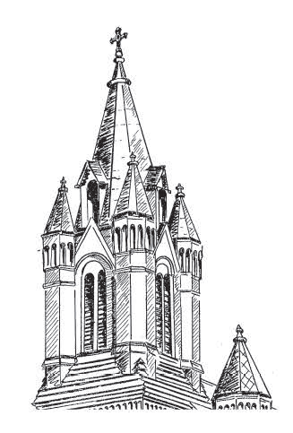
Festival de la Grande Eglise
(Festival of the Big Church)
St. Landry Catholic Church
“Mother Church of Acadiana”
October 6, 2018

Presenting Sponsor
Jambalaya Cook-off
Timeline
- Teams setup/Check in 8:00 – 8:30 a.m.
- Ready to Serve Samples 11:00 a.m.
- Serving, Judging & People’s Choice 11:00 – 2:30 p.m.
- Award Prizes 3:00 p.m.
- Clean up 3:30 p.m.+

Entry Fee - $50.00 per Team. Upon check-in, Teams will be assigned a number and a ticket box. This number will be used by the public to identify your team in the competition. Your Team Number must be on your ticket box for the People’s Choice voting.

Cooking Location – All food preparation must be done on site. You are welcome to decorate your booth (table and tent) for your Team.

Cooking & Ingredients – Teams must supply their own ingredients, cooking and cleaning supplies, serving utensils, tables, tent, and any other items needed to serve at least 100 people a sample size portion of jambalaya. Bringing a jug of water for cooking is recommended. Cooks must use their own recipe and can use any meat of their choice (pork, chicken, beef, turkey). Pre-cooked rice and pre-seasoned meat is allowed but any other pre-cooked or box items are not allowed.

Small Styrofoam bowls will be provided by the Festival. Teams should only serve to persons who have a bowl and a stamp on their hand. Please do not bring and hand out your own bowls. Use only the bowls provided by the Festival.

Awards – 1st Place Judge Winner will be selected by a panel of judges.
People’s Choice will be determined by ticket count at the end of the serving. Boxes will be collected when serving ends at 2:30 p.m. so the tickets can be counted. To increase the funds raised, anyone can purchase additional tickets for $1 each. Encourage your fans to stuff your box!

Clean Up – Each team is responsible for the cleanup of their own area. Trash cans will be available throughout the area.

Registration – Print form and mail along with your check for entry to: St. Landry Catholic Church, Jambalaya Cook-off, 1020 N. Main St., Opelousas, LA 70570. (Make checks payable to St. Landry Catholic Church). Please return forms by September 28th so we can ensure adequate supplies. If after the deadline, please contact us.

Contact Information: If additional information is needed, please contact us by email at jgodchaux@dcgagency.com or by phone at (337) 942-0253. Please indicate you are calling about the Festival de la Grande Eglise Jambalaya Cook-off.

Team/Organization Name:__________________________________ Team Leader/Individual:__________________________
Sponsor Name:___________________________________________ Number of Team Members:_______________________

I, __________________________________________, as Team Leader for _______________________________________,
understand and agree to abide by the above guidelines and rules for the Festival de la Grande Eglise Cook-off.
___________________________________________________ ________________________
Individual/Team Leader Date Phone Number(s)

Team # (Assigned by committee)
__________________________________________________________
Email(s)

